**ELECTRICAL AND ELECTRONICS ENGINEERING**

**Vision**

To be an excellent centre for the fundamental education in the field of Electrical &  
Electronics Engineering and to reach the needs of industry, academia and community.

**Mission**

* M1: To provide quality education in the area of Electrical & Electronics Engineering for increasing the opportunities in higher education & employment by giving the best practice of teaching-learning process.
* M2: To impart the value-based system of education by providing professional ethics & good communication skills to meet the challenges in the society.
* M3: To provide practical knowledge to students by collaborating with industry, research organizations and academia to encourage creativity and innovation.

**Program Educational Objectives Statements**

* Graduates will pursue higher education.
* Graduates will have successful career opportunities in Electrical & Electronics industries and other institutions.
* Graduates will exhibit leadership qualities with professional ethics for the development of society.

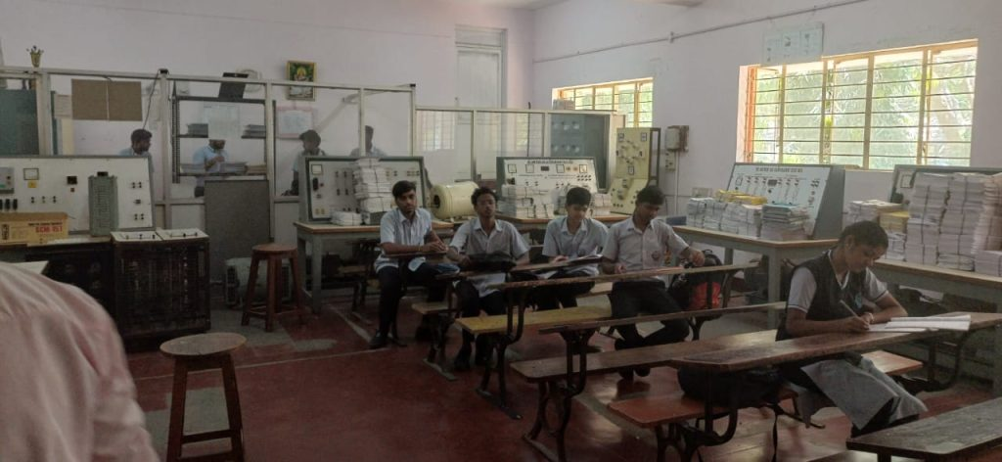

**FROM HOD’S DESK**

* Electrical and Electronics Engineering programme was established in the year 2007- 08, recognised by DTE, Bengaluru and affiliated to AICTE, New Delhi. The current intake is 40 students.
* The department has well qualified and experienced teaching faculty.
* The core courses of Electrical and Electronics Engineering programme offers a variety of opportunities to the aspirants be it for securing employment or to grow as an entrepreneur.
* At the end of the course, the students will be able to apply the knowledge acquired to identify, design/ redesign and solve Engineering problems.
* Many students are either employees of prestigious organisations like L&T, TRIPHASE Technology, Asian Paints, ABB, Toyota Kirloskar, Wipro or pursuing their higher studies in coveted institutions, like RVCE, SJCE, NIE.
* Staff and students are provided with unlimited free internet access at e-Library during spare time, so that they can develop and enhance their knowledge acquired in class rooms.

|  |  |  |  |
| --- | --- | --- | --- |
| **LIST OF TEACHING FACULTY** | | | |
|  |  |  |  |

|  |  |  |  |  |  |  |
| --- | --- | --- | --- | --- | --- | --- |
| **SL No.** | **Image** | **NAME** | **DESIGNATION** | **QUALIFICATION** | **Date of Joining** | **PROFILE** |
| 1 |  | Prathibha.B | HOD | MTech | 01-01-2009 | [click here](https://docs.google.com/document/d/14hUatX0ACDfK5X-P07JT9rU7cc6WztRH/edit?usp=drive_link&ouid=112397367595102276098&rtpof=true&sd=true) |
| 2 |  | Sadhana M.V | Lecturer | MTech | 01-01-2010 | [click here to view](https://docs.google.com/document/d/1IlXhn2seKqPuw8IyC674EmW_0J63HCWt/edit?usp=drive_link&ouid=112397367595102276098&rtpof=true&sd=true) |
| 3 |  | Sneha. S | Lecturer | MTech | 29/7/2010 | [click here to view](https://docs.google.com/document/d/1VxnUB0TnTq9k8SHwP81wFJFR8f-llRbq/edit?usp=drive_link&ouid=112397367595102276098&rtpof=true&sd=true) |
| 4 |  | Shwetha. M.P | Lecturer | MTech | 28/2/2011 | [click here to view the profile](https://docs.google.com/document/d/1ssOncoaeBaUtd5ED5e0mis3DdOO73JcT/edit?usp=drive_link&ouid=112397367595102276098&rtpof=true&sd=true) |
| 5 |  | Vidya | Lecturer | BE | 01-10-2023 | [click here to view](https://docs.google.com/document/d/1niDN6dX8NcbUEwgldhXgfQDFry10HAvR/edit?usp=drive_link&ouid=112397367595102276098&rtpof=true&sd=true) |

|  |  |  |  |
| --- | --- | --- | --- |
| **LIST OF SUPPORTING STAFF** | | | |
| **SL No.** | **Image** | **NAME** | **DESIGNATION** | **QUALIFICATION** |
| 1 |  | Madhusudhan N B | Instructor | BE |
| 2 |  | Ravi S K | Mechanic | ITI |
| 3 |  | Somashekara A N | Helper | ITI |
| 4 |  | Prashanth H S | Helper | ITI |